Oracle Manage services Project – ITC_Salam

This document is prepared to assist the procedure for accessing the RDP’s.

Terminal Servers in the environment: -
Table. 1.1
Step 1:-
Connect to Salam VPN,
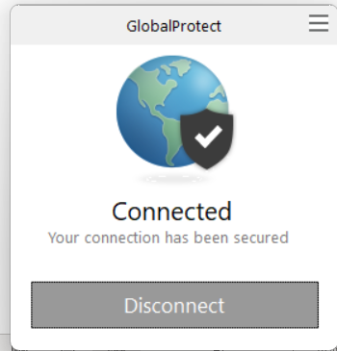
Step 2:-
Open remote desktop connection utility
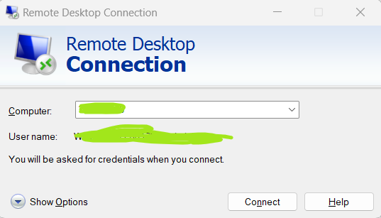
Step 3:-
Login to the Terminal server Ips as given Table. 1.1
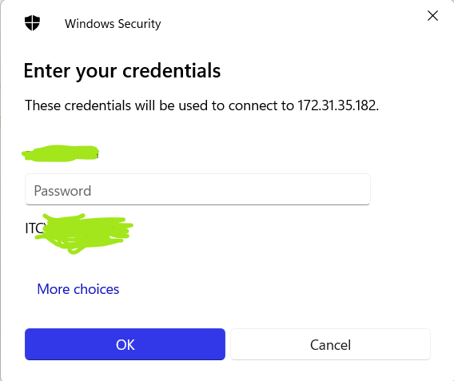
Step 4:-
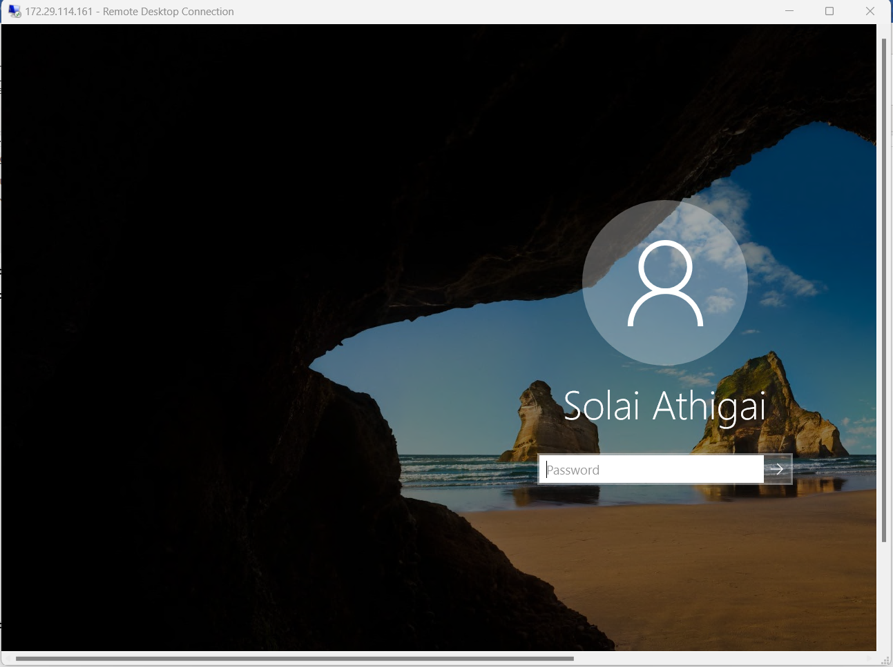
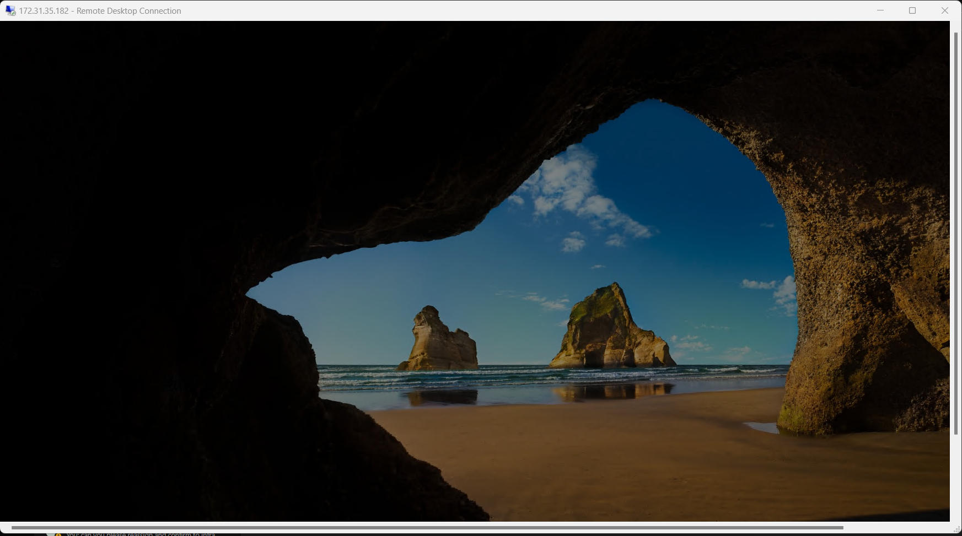

Please keep updating this document if infra Team provisions any new Jump/ Terminal servers.

